Illegal Behavior  Any staff member who witnesses illegal behavior will notify his or her immediate supervisor who will contact the police when necessary. Illegal behavior includes but is not limited to:  - Assault  - Criminal Mischief  - Drunk or Disorderly Conduct  - Harassment  - Public Lewdness  - Theft (Larceny)  - Trespass  - Controlled Substance or Alcohol | The Columbia Public Library Board of Directors has established certain standards of acceptable behavior on library property in order to maintain an atmosphere that promotes the use and enjoyment of the resources and services of the library, promotes the safety of the general public and the library staff, and protects the building, furniture, equipment, and materials of the library.  Any activity that interferes with the rights of other patrons to use the library; disrupts the normal functioning of the library; could result in physical, emotional, or mental injury to oneself or others; or could result in damage to the facilities, equipment, or materials is considered disruptive and unacceptable behavior.  The library reserves the right to require anyone who engages in disruptive behavior to leave the premises and the right to restrict privileges for a specified period of time or permanently. In most cases, a staff member will notify the individual that he or she is in violation of the standards of conduct and will provide one verbal warning. Unlawful activities will be reported immediately to the police. | Patron  Conduct  Policy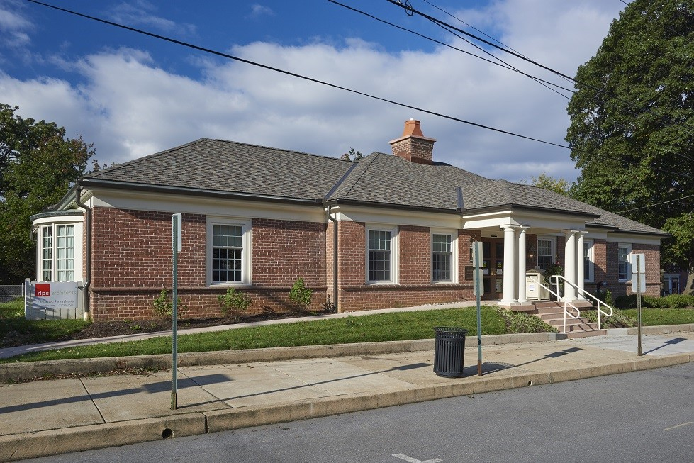  Columbia Public Library  24 South Sixth Street  Columbia, PA 17512  (717) 684-2255  www.columbiapubliclibrary.org
The following are NOT permitted at the Columbia Public Library:  Loud Talking and Laughing. If one person or group is heard above the general noise level in the library, this person or group will be requested to lower their voices.  Fighting. Includes any kind of fighting, real or pretend.  Throwing Objects.  Boisterous Behavior. Includes running, horseplay, and annoying other patrons.  Cellular or portable phones. Conversations MUST take place outside of the library.  Abusive or Obscene Language or Gestures. Includes language or gestures that convey sexually specific messages or are conveyed in a coarse or crude manner and any language that verbally abuses another individual.  Solicitation. No solicitation.  Eating and Drinking. Food and/or beverages are not allowed in the library. | Smoking. No smoking in the library, at or around entrances, or on library sidewalks in front of the building.  Sleeping. No sleeping.  Loitering. No one is permitted to monopolize library space without using the library’s resources.  Animals. Animals of any kind are prohibited, unless serving as an ADA stipulated assistance animal or part of a library-sponsored program.  Unattended Children. A parent, guardian, or other responsible adult must always accompany children under the age of 10 in the library.  Attire. Patrons must wear shoes and shirt in the library building.  Abuse of Library Equipment, Furniture, and Materials.  Bikes, Rollerblades, Skateboards, and Scooters. Must not be ridden anywhere on the library property.  Blocking Seating Areas, Aisles, or Doorways with excessive personal items, shopping carts, bicycles, or other large, wheeled conveyances is not permitted inside the library building. | Weapons. Carrying weapons of any type on library property is not permissible except by law enforcement officials.  Removing Library Materials or Equipment. Staff members must check out all circulating materials before they can be removed from library property.  Playing Music. Includes playing music or other types of media at a level that is disruptive to other patrons.  Excessive Displays of Affection. Includes any sexual conduct or physical contact deemed inappropriate for a public place.  Hygiene. A person may be requested to leave the library if his/her personal hygiene interferes with the orderly operation of the library or with the ability of the other patrons to use and enjoy the facility.  Misuse of Restrooms. Includes excessive visits or using the restrooms as a laundry or bathing facility. Must have photo ID or library card to use restroom.  The Library is NOT responsible for personal items that are lost, stolen, or damaged on library property.

